**Muhammad Umer**

**F178224**

**Black Box**

Because the human brain doesn't work that way we have no good way of knowing what exactly the algorithm is doing or what methods it is using. This has been called the “**black box problem**” because during these times AI seems to emulate a **black box** that has no way of looking inside.

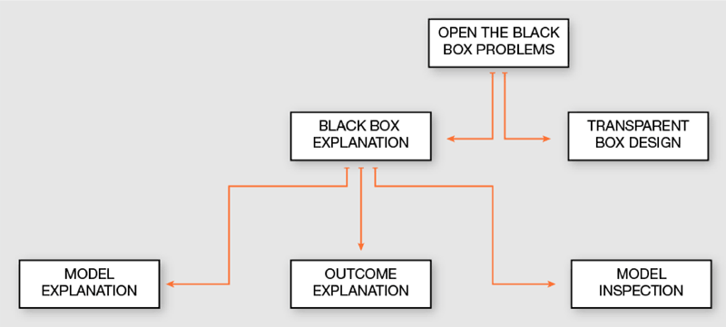

Many ways are being used to solve this problem, some people are using visualization and by graphs.

There is a way to solve this problem by **“Deep or Feature Visualizing”** (visualizing all the neuron when they are doing training on the data). Here is the [link](https://ai.googleblog.com/2017/11/feature-visualization.html)

**Machine Learning**

**SVM Model**

A support vector machine (SVM) is a supervised [machine learning](http://www.monkeylearn.com/machine-learning/) model that uses classification algorithms for two-group classification problems. After giving an SVM model sets of labeled training data for each category, they’re able to categorize new text.

So you’re working on a text classification problem.

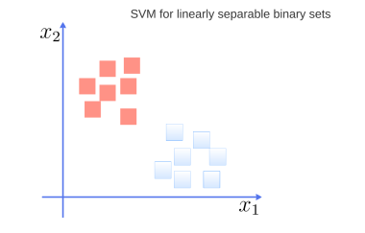

Basically svm model classify the data into two classes, as shown in figure below:

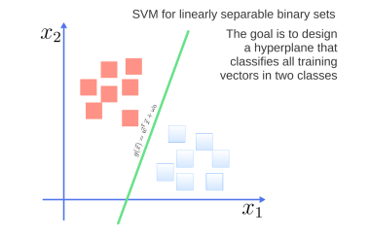

**Logistic Regression**

[**Logistic regression**](https://www.statisticssolutions.com/academic-solutions/membership-resources/member-profile/data-analysis-plan-templates/data-analysis-plan-logistic-regression/) is the appropriate regression analysis to conduct when the dependent variable is dichotomous (binary). The data should be converted into binary form (0,1). For converting data into binary form we can use label encoding and one hot encoding.

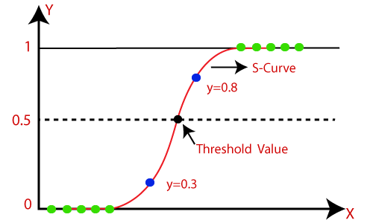

**Deep Learning Neural Network**

Softmax is an activation function. Other activation functions include RELU and Sigmoid. It is frequently used in classifications. Softmax output is large if the score (input called logit) is large. These functions uses learning rate, optimizer function and epochs.

